**Create ActiveMQ Artemis broker**

Steps :

1. Traverse to ActiveMQ Artemis bin folder and hit following command.

Example : 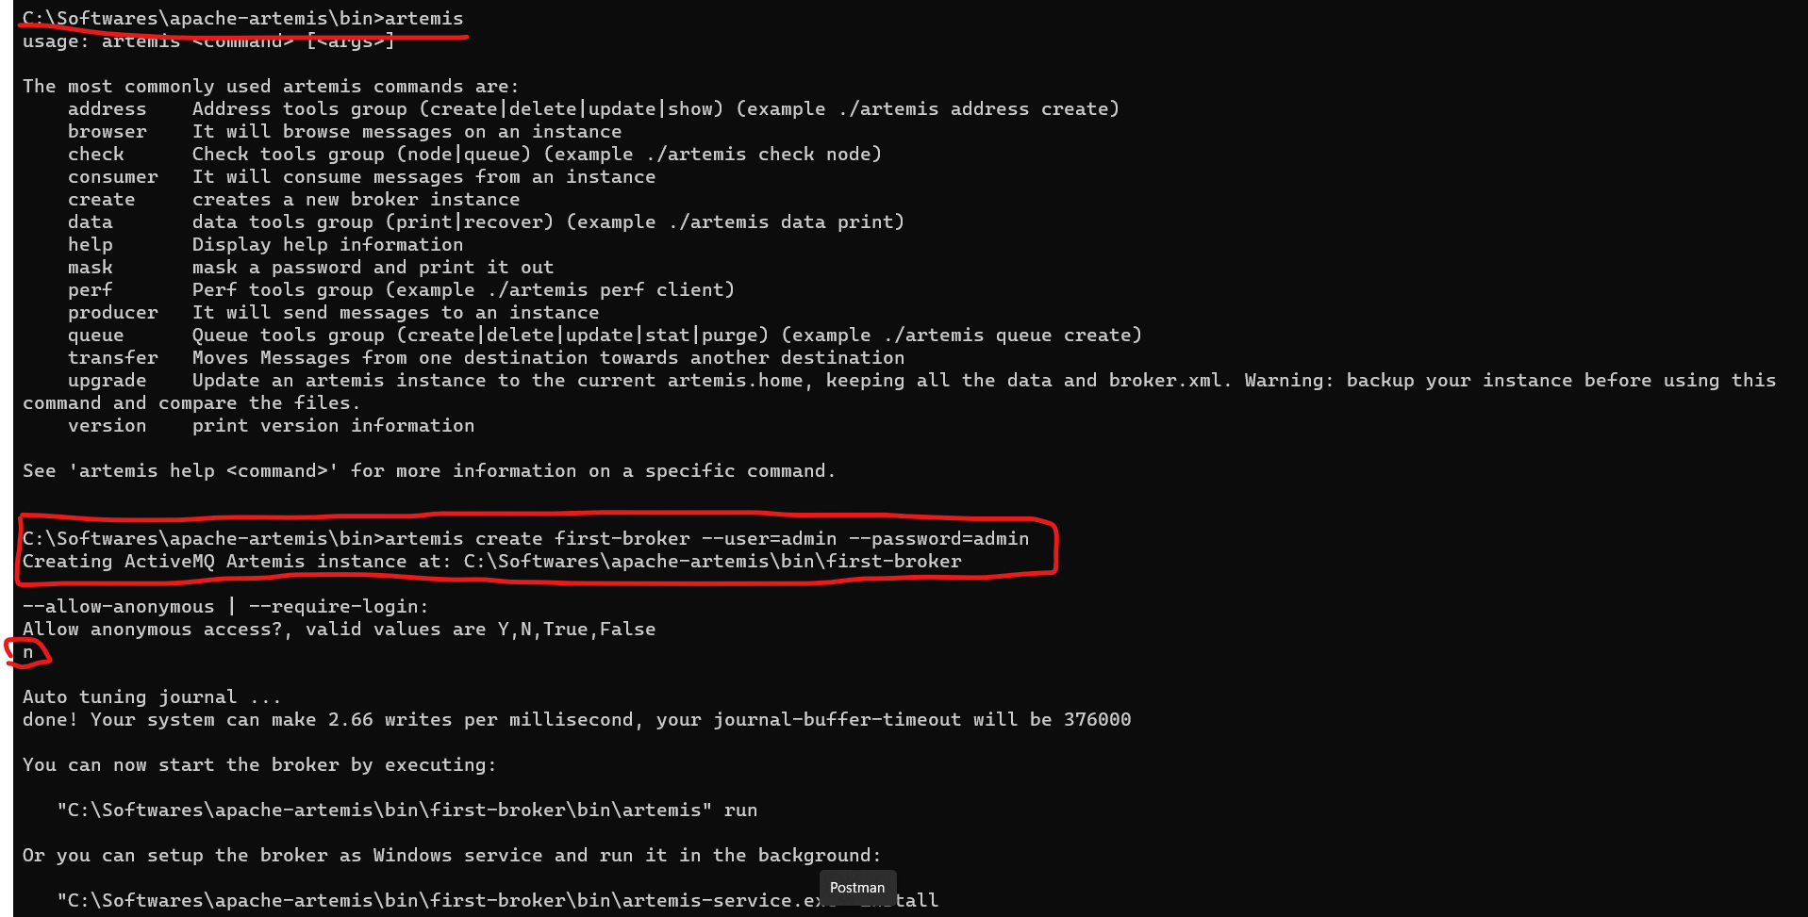

1. Verify the broker folder is created inside the bin folder.

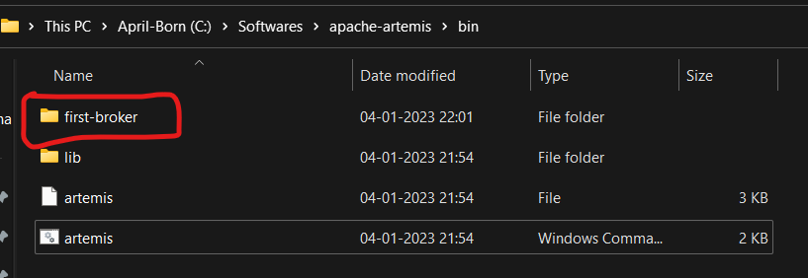

1. Now open the command prompt with admin account (or run as administrator) and traverse to created broker folder’s bin folder.

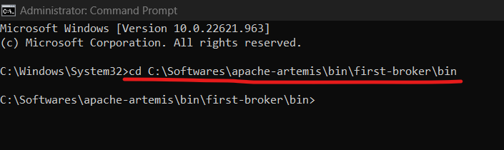

1. Now you will see following files in first-broker’s bin folder.

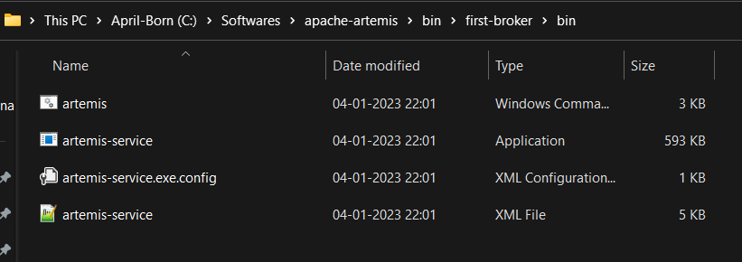

1. Run the following two commands.
   1. Artemis-service.exe install
   2. Artemis-service.exe start

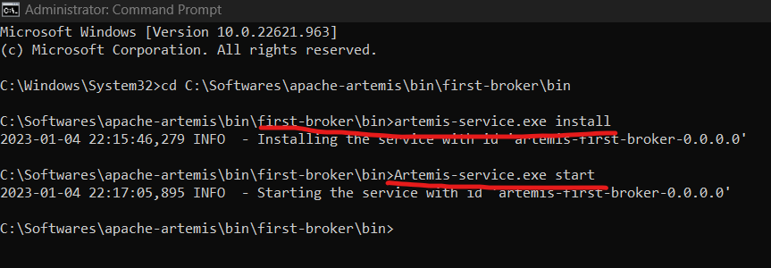

1. Now access the artemis into browser by entering – <http://localhost:8161>

Enter the username and password which you have set in the first step.

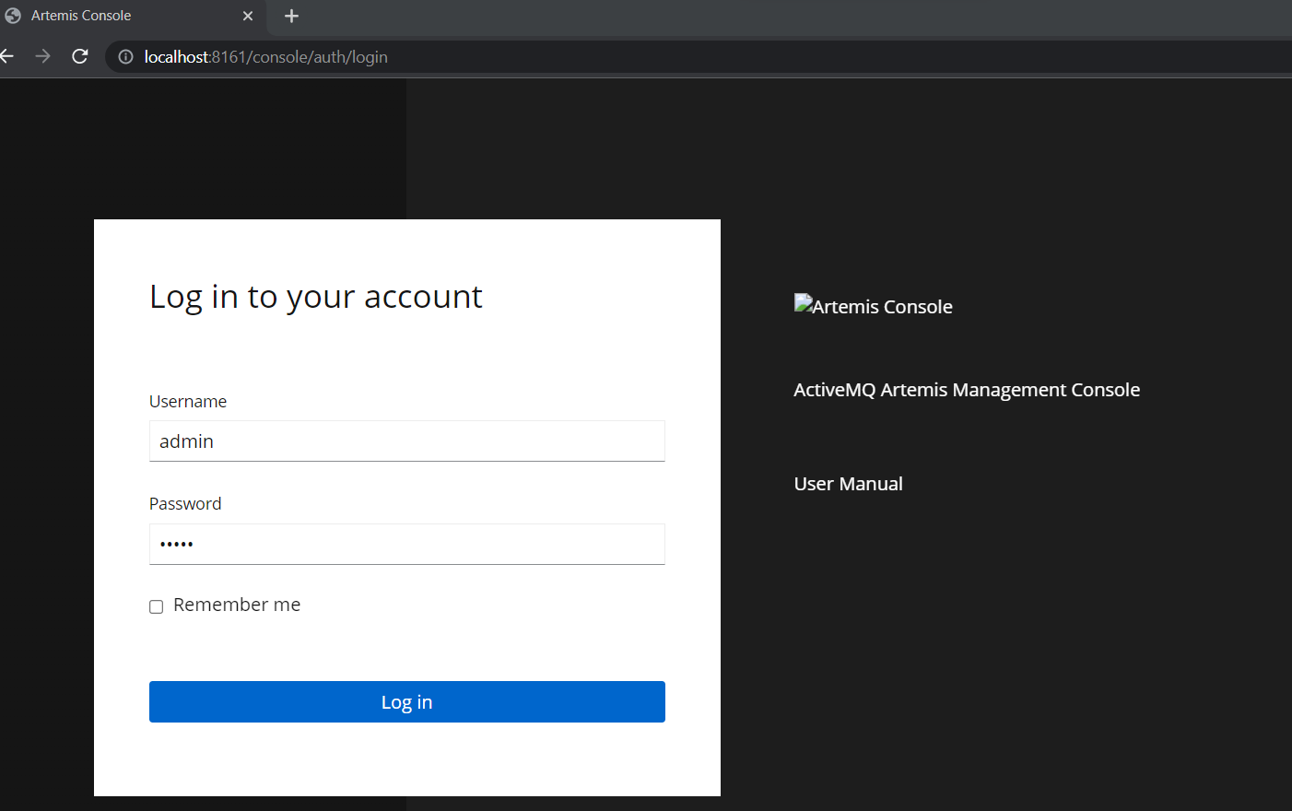

1. Following will be the default setting and queues.

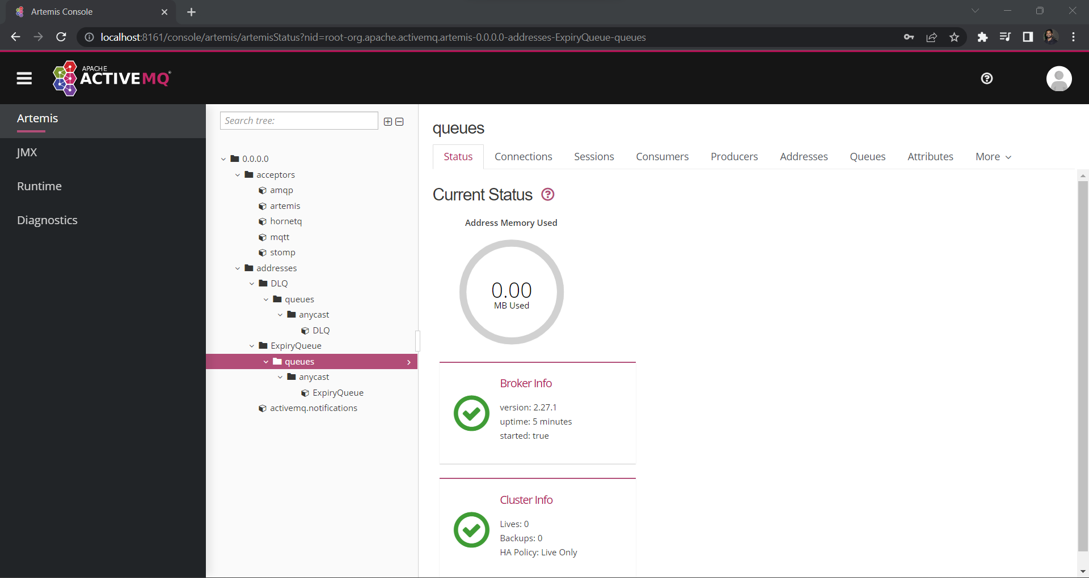

1. Run Your spring boot app which is creating and sending the messages to Queue. Now you will be able to see the Queue is created on ActiveMQ Artemis Dashboard. If not created then send the message onto queue where in my case I need to hit the rest endpoint then queue name will be displayed.

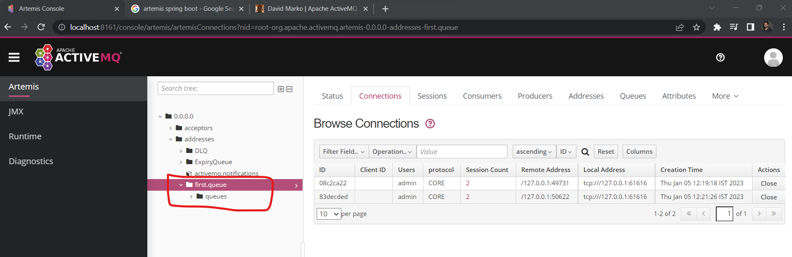

Example :

1. Sender :

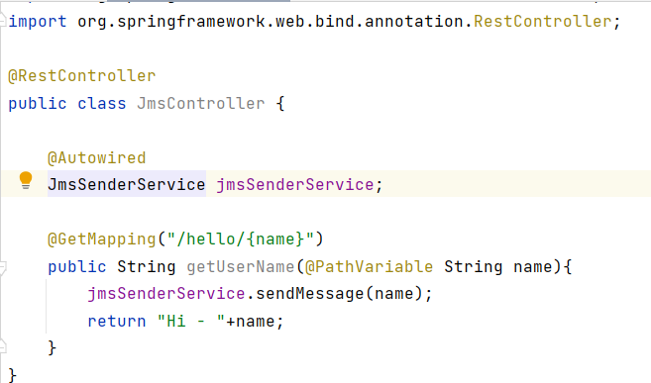

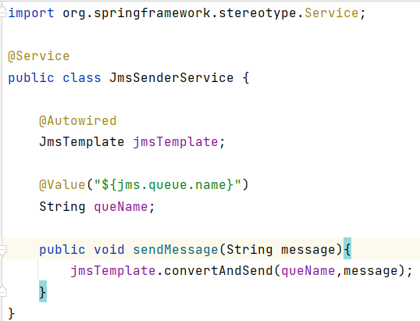

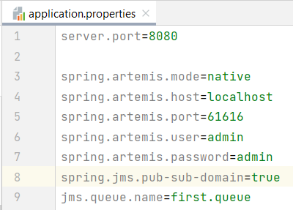

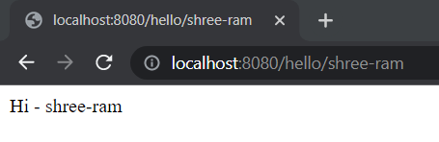

1. Receiver:

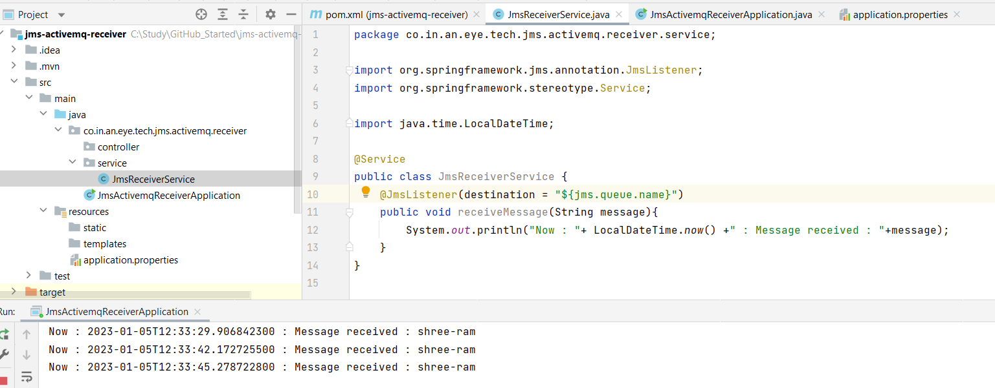

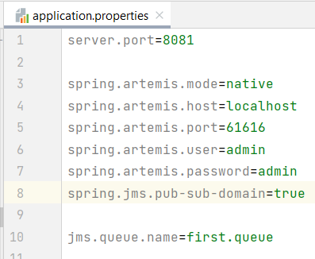

1. To stop the broker hit. Run the following two commands.
   1. Artemis-service.exe uninstall
   2. Artemis-service.exe stop